Qn2. What is the difference between == and === in javascript?

In javascript both == and === are the equality operators.

But the difference is, in == it will check for the values and in === it will check for the values and the datatypes.

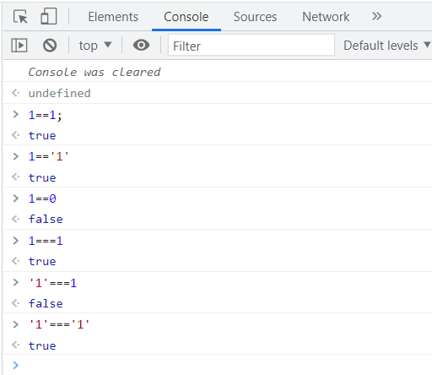

In the above example,

1==1 is true because the both the values are same.

1==’1’ is also true even though the data type is different, the values are same.

1==0 is false, the values are different

1===1 is true because the values and the data types are same

1===’1’ is false since the one in number and the other is a string

‘1’===’1’ is true since both the values and the data type is same.